**Week 8**

1. **Git-HOL HandsOn**

Step 1

*Setting Up Git Configuration*



*User Level Configuration of User ID and User email ID*



Step 2









Step 3



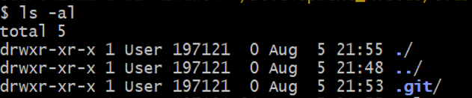



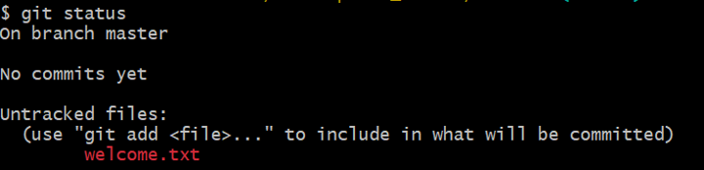

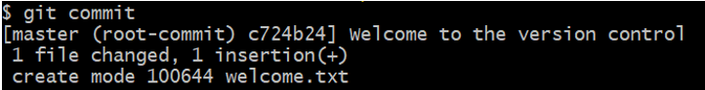

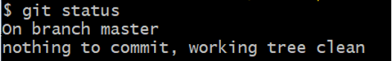



**GitLab Output**

